INPUT/OUTPUT AND ERROR HANDLING

EC 5080

SOFTWARE CONSTRUCTION

WIJAYAWARDHANA W.A.H.A.

2019/E/166

SEMESTER 05

16 SEPTEMBER 2022

QUESTION 01

PART 02

Test1

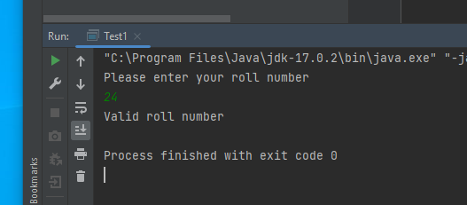

FIGURE 01 - OUTPUT

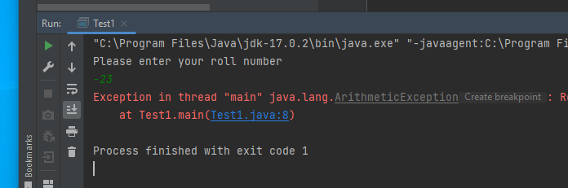

FIGURE 02 – OUTPUT

Test2

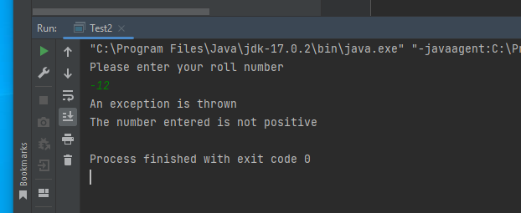

FIGURE 03 – OUTPUT

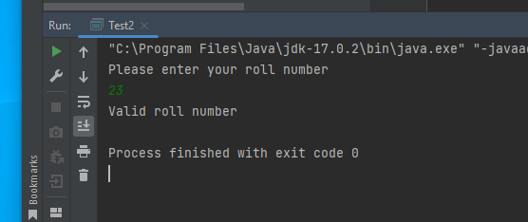

FIGURE 04 – OUTPUT

Test3

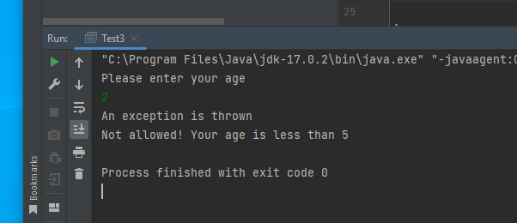

FIGURE 05 – OUTPUT

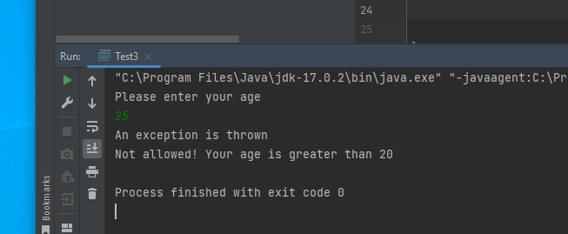

FIGURE 06 – OUTPUT

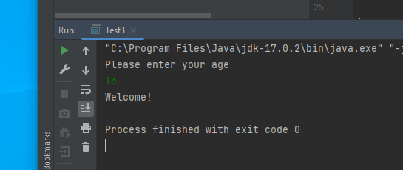

FIGURE 07 – OUTPUT

Test4

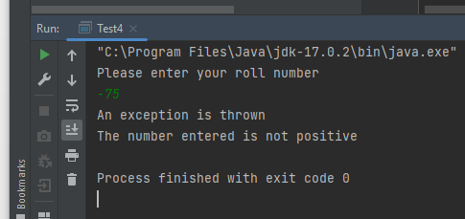

FIGURE 08 – OUTPUT

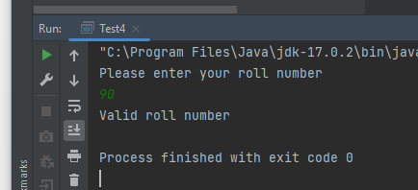

FIGURE 09 – OUTPUT

Test5

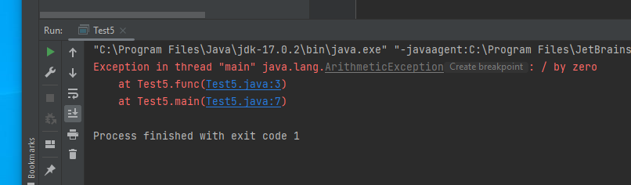

FIGURE 10 – OUTPUT

Test6

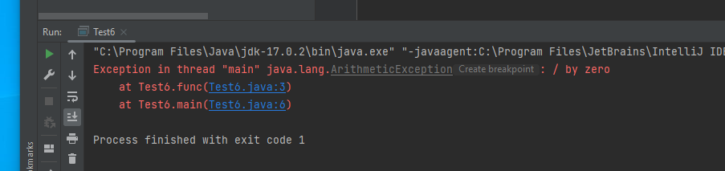

FIGURE 11 – OUTPUT

Test7

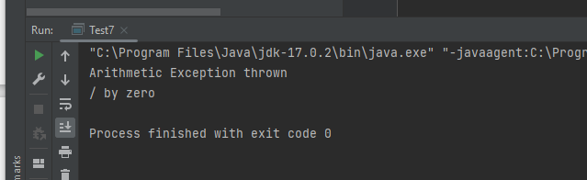

FIGURE 12 – OUTPUT

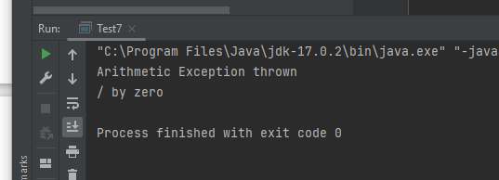

FIGURE 13 – OUTPUT